The Ministry of Education and Science of the Republic of Kazakhstan
East Kazakhstan State Technical University. D.Serikbaev
Faculty «Faculty of Sciences of the Earth"
Department of "Geology and mining"

GOLD-RARE METAL DEPOSITS

Deposits can be medium, large and giant. There are 18 groups of deposits in this deposit type.
Location of gold-rare metal deposits
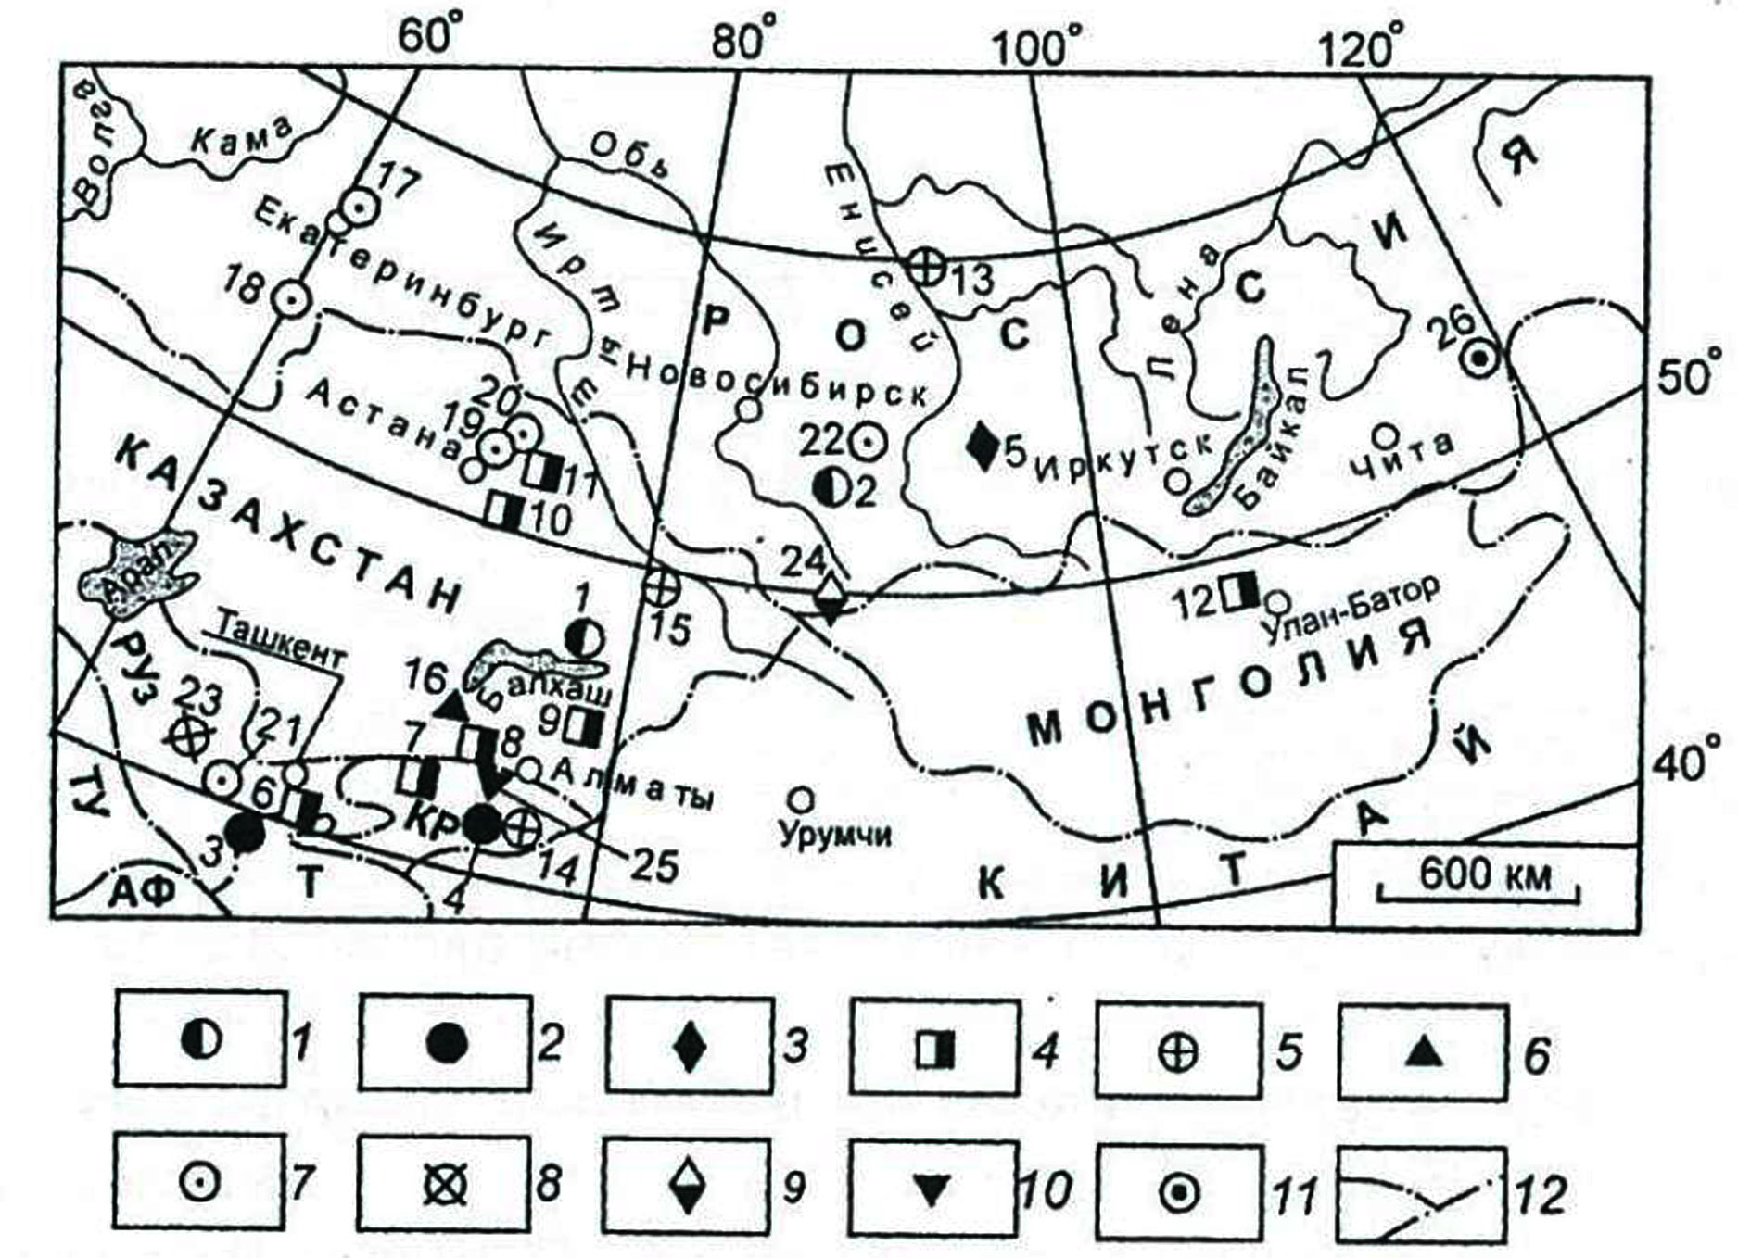
GOLD-rare metal deposits
Gold-rare metal deposits of Central Asia with different ratio rating of Au, W, Mo, Sn, Be, Ta and Nb was formed in final stages of Paleozoic and Mesozoic tectonic cycles, closely connected with orogenic and intraplate (granodiorite-granite-leucogranite) magmatism sings.
Main groups of deposits:
- Gold-tungstic;
- Gold-molybdenic;
- Gold-stannic;
- Gold-beryllium-stanum-tantalum-niobic.
1. Gold-tungstic deposits
1.1 Gold-tungstic deposits of mesothermal facies
1.1.1 Skarn, veined and stockwork type facies in endo/exo-contact zone of intrusic body (3-6km)(Djilau deposit in West Usbekistan, Koytash);
1.1.2 Gold-rare metals stockwork facies in superintrusive zone (2-4 km) (Muruntau ore field in Usbekistan)
1.1.3 Bulk sulphidized deposit and quartz reef system of black-shale type in distant intrusive zone (1-3km) (Deposits: Kumtor in Kyrgyzstan; Olympiadinskoye and Nezhdaninskoe in Russia; Kokpatas in Uzbekistan; Bakirchik in Kazakhstan)
1.2 Blocker (bottomman) zone of gold-tungstic deposit distribution area (Deposits: Berezovskoe in Russia; Zholimbet and Bestobe in Central Kazakhstan)
1.3 Gold-tungstic deposits of volcanic facies (Mironovskoe deposit in Kyrgyzstan).

2. Gold-molybdenic deposits
There are two facies relationship types of Au-Mo deposits:
2.1 Methotermal, in contact with differentiated (often large) source of granitoidal magnetism (3-6 km) (Deposits: Kluchevskoe ore field; Shatirkol; Kordaiskoe; Sayakskoe ore field in Central Kazakhstan; Karachoko in East Kazakhstan; Taskuduk);
2.2 Deposits of medium and shallow depth, in contact with: small hypabyssal intrusive; subvolcanic bodies and various dyke complex (1,5-4km) (Taldibulak in Kyrgyzstan; Kalmakir-Dalneye in Uzbekistan; Erdenet, Harmaktai in Mongolia; Nurkozgan, Koksai, Bozshakol in Kazakhstan; Kalgutinskoe; Chaglinka)

3. Gold-stannic deposits
Associated occurrence of Au and Sn occurs in mesothermal deposits of rare and precious metals.
Stannic adulteration occurs in shallow Au-Ag deposits of volcanic class.
Gold content of tin deposit rarely exceed tenth-hundredth part of total content, but floran-tin in goldfield do has mineralogical interest.
Standard example of this type is Tuskuduk stockwork deposit.

- Deposits of Au, Be, Sn, Ta and Nb
Representative of this type is Verhnemanskoe deposit
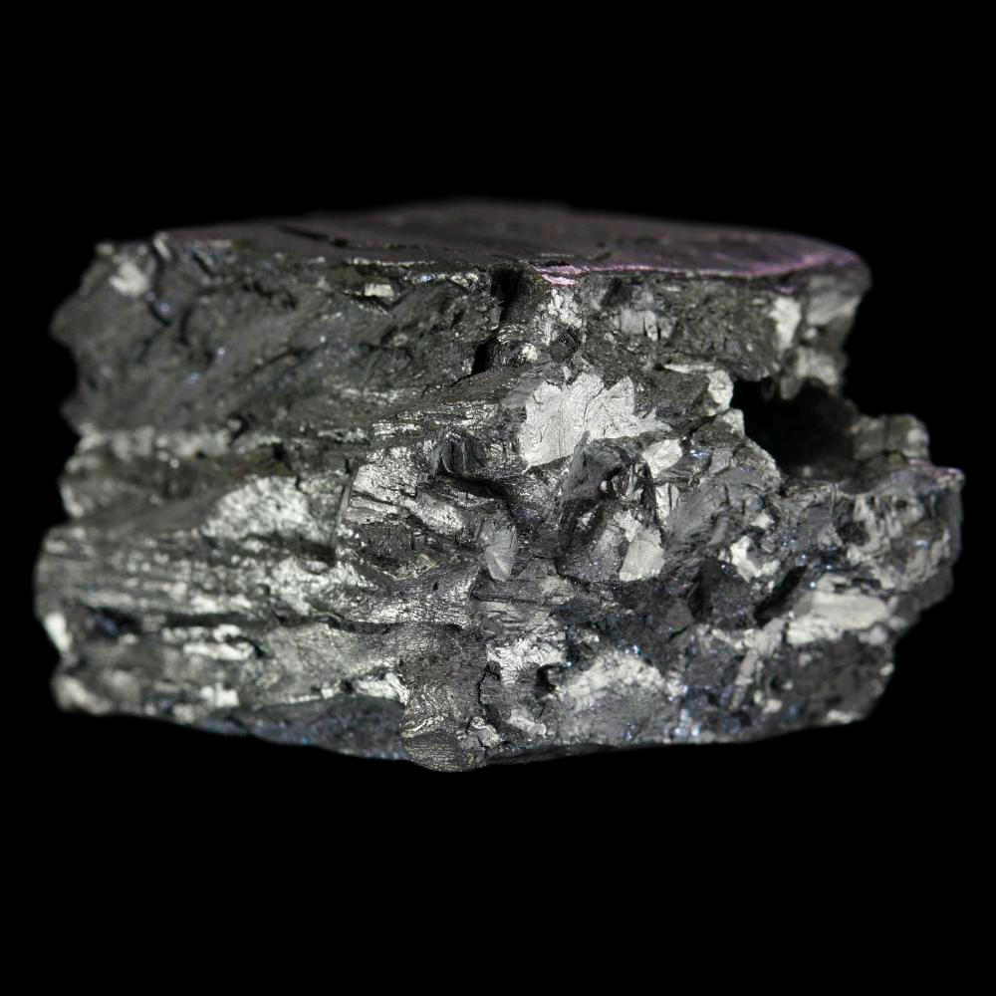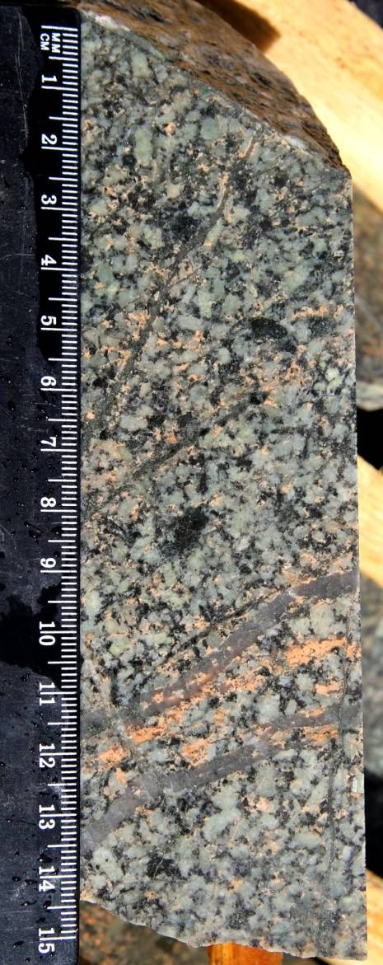

SUZDAL
REGIONAL GEOLOGY
The Suzdal deposit is situated in the Semipalatinsk Irtysh (Semey Ertis) region of Eastern Kazakhstan as an element of the West Kalba gold belt, which extends for 800 km in the northwestern direction with a width of 40–50 km. In the northeast, this belt borders on the Kalba–Narym raremetal belt along the Tereqty–Ulungur Fault and in the south west, on the Zharma–Saur copper–gold–raremetal belt along the BayguzinBulak Fault (D’yachkov, Titov, and Sapargaliev, 2009). The West Kalba gold belt is divided into two metallogenic zones separated by the Charsk (Shar)–Gornostaevka–Zimunay Fault.
In the 1970s–1980s, a large gold district was discovered in the northwestern part of the West Kalba gold belt in Eastern Kazakhstan as a result of extensive drilling of unexposed territories.The goldbearing weathering mantles were the main objects of mining in past years. The geology and genesis of the large Suzdal deposit remain poorly elucidated in the literature. This deposit is an example of the important geological and economic type of gold–sulfide mineralized zoneshosted in black shale. The geology of the Suzdal deposit has been described in many publications (Begaev and Stepanenko, 1995; Malygin, Nachtigal, and Begaev, 1995; Shcherba et al., 1998, 2000; Zeilik, 2001; Kalinin, Roslyakov, and Prudnikov, 2006; Kalinin et al., 2009; Rafailovich, 2009; Kovalev et al., 2009, 2011).

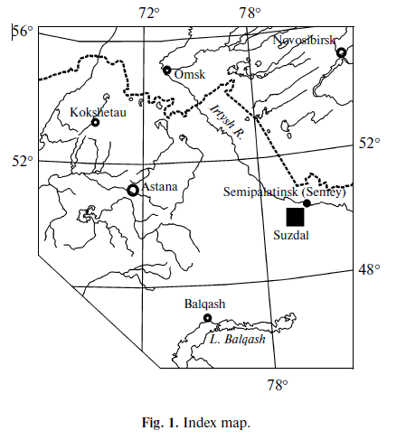
The Suzdal gold–sulfide deposit is situated in the northwestern part of the West Kalba gold belt in Eastern Kazakhstan and belongs to the genetic type of stringer–disseminated mineralized zones hosted in the Lower Carboniferous blackshale volcanic–carbonate–terrigenous sequences. Mineralization is controlled by the NEtrending Suzdal Fault. In the north, the deposit borders on the Early Triassic Semeytau volcanic– plutonic structure. Mineralization is superposed on the Late Paleozoic complex of metadolerite and quartz porphyry dikes. Ore deposition was a longterm process comprising four stages. The first stage was related to deposition of slightly auriferous pyrite syngenetic to host rocks. The second stage is characterized by formation of the first productive (with invisible gold) fineacicular arsenopyrite mineralization accompanied by sericitization and localized in the tectonic zone. The stockwork ore with pocket–disseminated basemetal mineralization and free microscopic gold of the third stage is hosted in silicified rocks. The ore formation has been completed by quartz–stibnite veins superposed on all preceding types of mineralization. According to Ar/Ar dating of sericite, a chronological gap between the second and the third stages is estimated at 33 Ma. The deposit is an example of polygenetic and multistage mineralization.

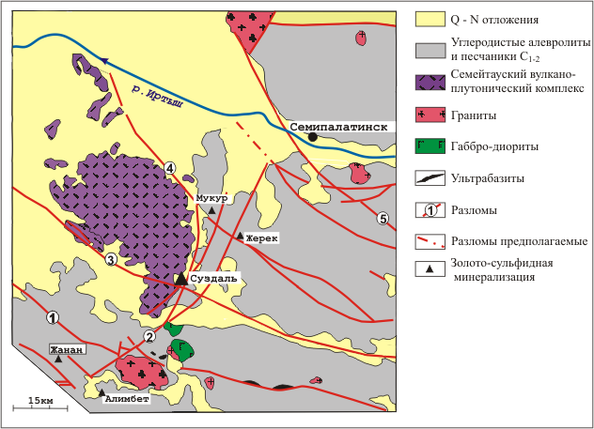

The schematic geological map of the Semipalatinsk Irtysh area
Faults: 1 - Baiguzin-Bulak, Suzdal 2, 3 - Chara-Gornostaevsky, 4 - Mukursky, 5 - West Kalba.

Magmatism. The complex of mafic and felsic dikes and other minor intrusions is controlled by the Suzdal Fault Zone. The widespread mafic dikes are not observable at the surface or in the weathering mantle but are crossed by drill holes beneath Cenozoic sediments at a depth of 50–70 m and traced to a depth of 500–700 m as crosscutting or nearly conformable bodies relative to the country volcanic–terrigenous–carbonate rocks. Strongly altered felsic dikes are mapped at the surface mainly in the eastern part of the deposit. A dikeshaped felsic intrusion about 50 m thick and containing xenoliths of mafic dikes was crossed near ore zone 4 at a depth of 500–700 m .
Host rocks. Lower and Upper Carboniferous rocksoccur at the deposit. Mineralization is hosted in the Visean carbonaceous terrigenous–carbonate–volcanic rocks of the Arkalyk Formation and the Serpukhovian terrigenous rocks . The Upper Carboniferous molasse, which occurs at the northeastern flank of the deposit, is overthrust by a Lower
Carboniferous sequence along the Gornostaevka Fault. The sequences of orebearing rocks consist of sandstone, carbonaceous silty shale, оrganogenic limestone, sedimentary limestone breccia and bioclastic rocks, interbeds of Mg–Fe carbonates and cherty claystone, basaltic andesite (lavas and tuffs). Carbon ate rocks of the Arkalyk Formation dominate in the east of the deposit. In the west, the orebodies are hosted in the intensely foliated Serpukhovian carbonaceous silty shale and sandstone of flyschoid turbidites. All rocks underwent regional metamorphism at the level of lower greenschist facies.

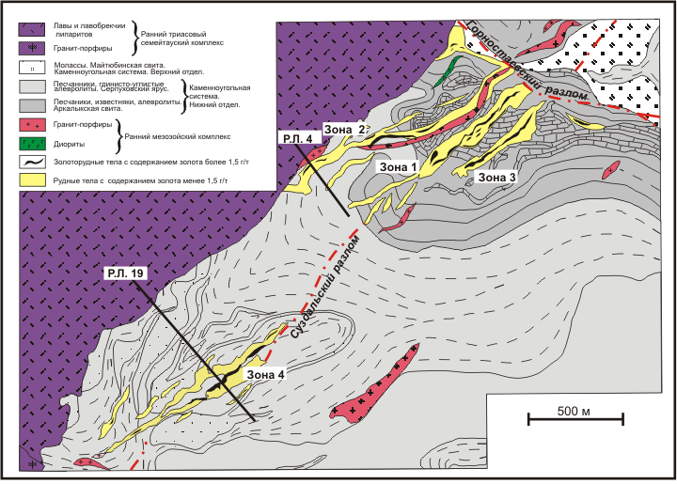
Geological scheme of the Suzdal deposit

Morphology of ore lodes. Gold–sulfide mineralization is localized in ore zones 1–4 pertaining to the NEtrending Suzdal Fault System . The ore bodies have vague boundaries, which are established only from results of sampling. Ore mineralization is traced to a depth greater than 600 m, and the average Au grade remains almost the same over the entire depth interval, having a wide dispersion. The contribution of pyrrhotite increases with depth.

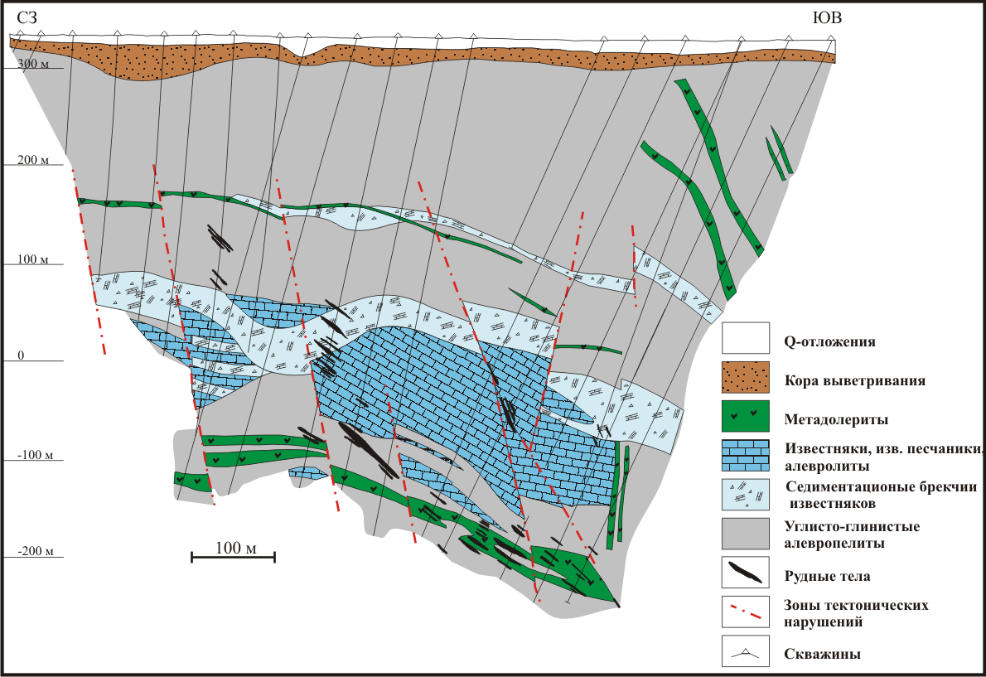

The schematic geological section on the survey line 4

Mineralization and wallrock alteration. Primary gold mineralization is combined at the deposit with Aubearing weathering mantle, which has been mined out in the last decade. The structure, morphology, mineralogy, and geochemistry of the weathering mantle, as well as typomorphic features of supergene gold were considered in detail by Begaev and Stepanenko; Kalinin, Roslyakov, and Prudnikov (2006);and Kalinin et al. (2009). The Cretaceous–Paleogene linear and linear–areal weathering mantle at the deposit is 60–80 m thick. In general, the following zones are distinguished from top downward: variegated residual material consisting mainly of kaolinite with admixture of mixedlayer minerals and montmorillonite; structured residual kaolinite–hydromica material with admixture of montmorillonite and silica–goethite veinlets; saprolite consisting mainly of hydromica and characterized by wellpreserved protolith structure. The average Au grade remains approximately the same in all zones, varying from 0.5 to 104.2 gpt. The stable Au–As–Sb–W geochemical association is noted. The gold newly formed in the weathering mantle is characterized by morphological diversity comprising both crystalline individual grains and exotic intergrowths of crystallomorphic and sinter–conchiform grains. Several generations of gold differing in grain size and with tendency to upward enlargement of grains are established. Highfineness gold is predominant. The supergene gold was formed largely by dissolution of invisible gold contained in Aubearing sulfides, its local redistribution, and deposition under oxidizing conditions.

HISTORY
The first discoveries in the Talas Valley (Aktash skarn) were made in the 1930s, as part of a 1:500,000 geological mapping programme. A more systematic study of the region commenced in the 1960s with 1:50,000 geological mapping, ground geophysics (magnetic, IP), soil and chips geochemistry. The Soviet report, containing drilling data for Taldybulak, was completed in 1980. It reflects the works of 1977‐1980. This report contains two historic Soviet estimates for a porphyry Cu‐Au target located within the licence, calculated at a 0.1% Cu cut‐off‐grade (COG) to contain 253t Au, 751kt Cu, 30.2kt Mo and at a 0.15% Cu COG for 126t Au (0.91g/t Au), 384.5kt Cu (0.24% Cu), 15.5kt Mo (0.01% Mo). Despite this result, the project was abandoned for many years owing to its low copper grade.
Regional Setting
Tien Shan mountain belt
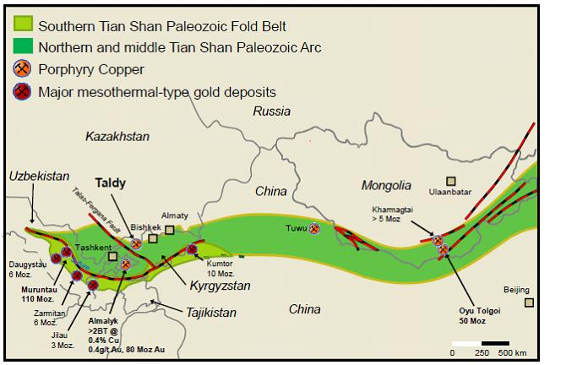
A HOST TO GIANT OROGENIC AU AND CU‐AU PORPHYRY DEPOSITS
The geology of Kyrgyzstan is dominated by the presence of the Tien Shan mountain belt, which forms an arc running through the country from west to east, with sub-parallel ranges separated by inter-mountain basins and valleys. The region identified today by the Tien Shan Mountains forms part of the Altaid orogenic collage, in which crustal movements have taken place since the Archean. Consequently, the Tien Shan can be subdivided into several separate tectonic provinces. These include the Northern Tien Shan, the Middle Tien Shan and the Southern Tian Shan.
Map of Kyrgyzstan showing three key tectonic provinces, their related geodynamic complexes, major faults and the metallogenic zones of the Northern Tien Shan.
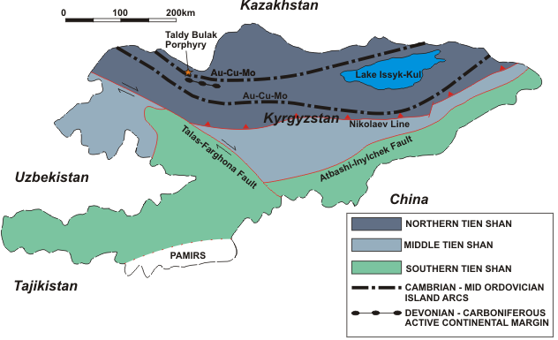
The Au-Cu/Mo mineralization within the NW of Kyrgyzstan is confined to an approximately 60km long E-W striking trend in Lower Palaeozoic volcaniclastic sediments, bounded by a Late Ordovician batholith in the west and east.
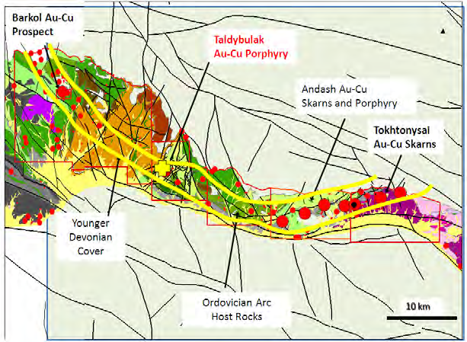
The Taldybulak deposit is situated within the Tien Shan Mountain system. This mountain belt lies in a zone in which crustal movements have taken place since the Archaean. It contains a wide variety of igneous, sedimentary and metamorphic rocks, formed at different periods under different geodynamic conditions. Taldybulak is situated in the northern Tien Shan. The Taldybulak gold-copper/molebdenium porphyry deposit is located within Talas-Kemin metallogenic zone. The porphyry consists of a circular quartz diorite stock complex (800m x 800m) of porphyry intrusive inter-fingering into an overlying volcanic-sediment package with numerous roof pendants and xenoliths of wall rock caught up in the porphyry. The quartz diorite stock intrudes into a lower Palaeozoic (late Cambrian to middle Ordovician) island arc volcanic-sedimentary sequence. Lower Palaeozoic sedimentary formations are interlaid with the island arc basaltic lavas and volcanic tuffs. The porphyry and wall rocks were subsequently intruded by numerous cross-cutting dyke phases intruding along pre-existing structures. Contacts with the wall rock are complex with numerous inter-fingering relationships. Throughout the deposit the stock contains numerous wall rock xenoliths. The porphyry has undergone multiple phases of intense alteration, some of which are linked to mineralisation. The porphyry stock has then been subjected to a later gold overprint along a steeply dipping 200m wide NW-SE structural zone which cuts across the porphyry stock. This has resulted in inconsistent Cu:Au ratios across the porphyry with gold introduced into both high and low grade copper zones.

Simplified geological map of the Taldybulak deposit, highlighting the horst structure formed by the two major N-S faults. The porphyry has been dated using U-Pb ICPMS zircon dating to give an age of 467-473Ma
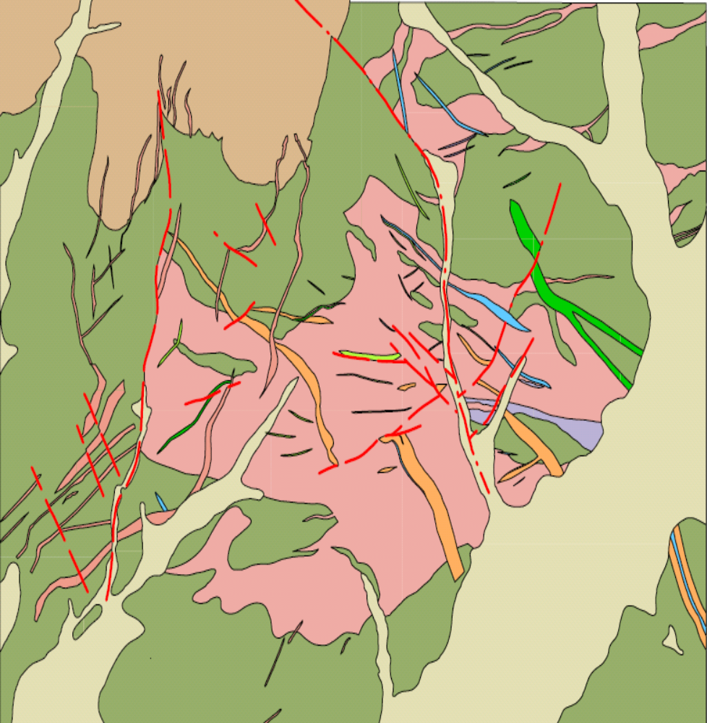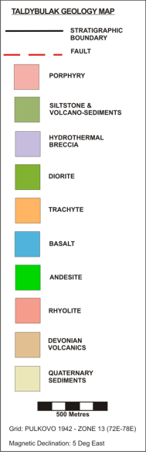

Average grade of metals
The resource model was estimated down to a depth of 1450m RL (approximately 600m below surface). The current global Indicated + Inferred resource for Taldybulak at a 0.30g/t Au cutoff is 291Mt at an average grade of 0.71g/t Au, 0.16% Cu and 0.01% Mo containing 7.7 M gold equivalent ozs. The in-pit resource at a 0.30g/t Au cutoff is 150Mt @ 0.74g/t Au, 0.17% Cu and 0.01% Mo containing 3.55M ozs Au and 257,000 tonnes Cu.

Schematic lithological cross section of Taldy Central S-N Section with drill holes and significant mineralised intervals overlain
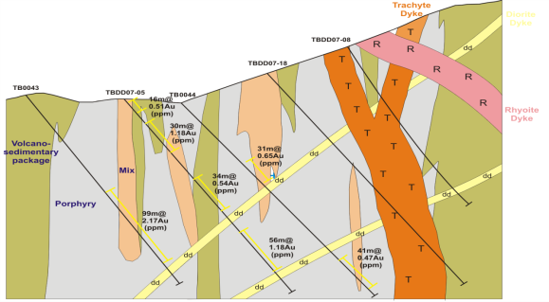
Detailed structural geology map of Taldybulak
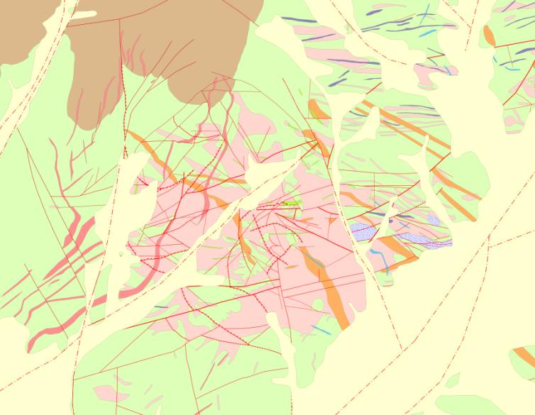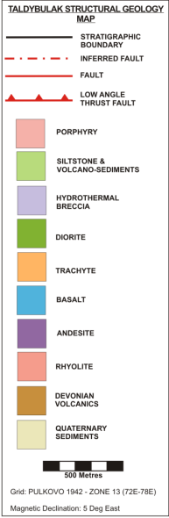
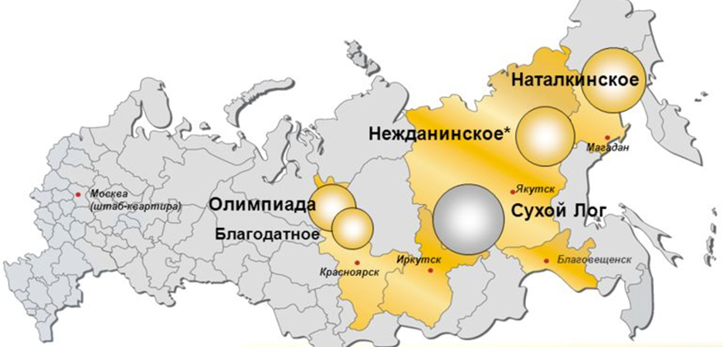
THE OLIMPIADA DEPOSIT

The deposit is located in the central part of the Yenisey Range (eastern Siberia) approximately 100 km to the south of the town of Severo-Yeniseysk.
Gold placers have been known in this area since the end of nineteenth century, but the geological mapping and exploration during the 1950s and the beginning of the 1960s discovered only occurrences of tungsten and antimony. Analyses of isolated grab samples at the middle of the 1960s conducted by Longin V. Lee showed presence of gold and initiated additional exploration. Economical gold mineralization was verified at the end of the 1970s.
The geology of the Olimpiada deposit has been described by Genkin A.D., Novozhilov Y.A., Lopatin V.A., Savelyev R.A., Gavrilov A.M., Sergeev N.B.

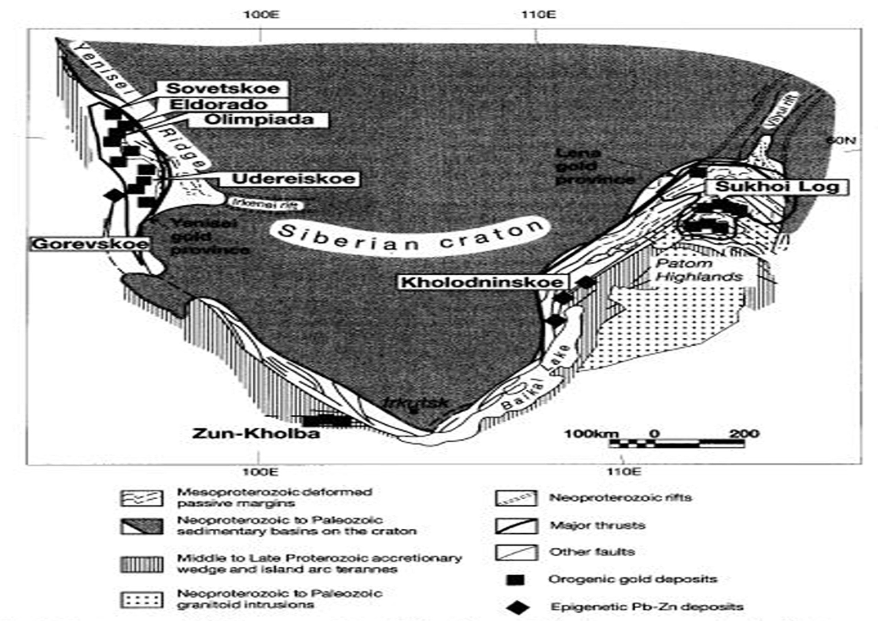

Stratigraphy
The Olimpiada deposit is located in the Late Proterozoic (Baikalian in Russian terminology) trough of Yenisey Range along the passive margin of Siberian continent (platform). The basement complex is represented here by Early Proterozoic (2,000-1,650 Ma) kyanite-staurolite, biotite-amphibole, and amphibole-bearing slates with interbeds of quartzite and marble.
The Middle-Late Proterozoic Kordinskaya and Gorbilokskaya suites of the Sukhopitskaya series consist of the marine carbonate-clay sediments that form the middle structure stage of the Yenisey trough. The Late Proterozoic-Cambrian orogenic and platform sediments represent its upper structure stage.
The Kordinskaya suite hosts the Olimpiada ore. The lower, 200-500 m thick, part of this suite consists (Lee et al. 1990) of calcareous to quartzose, biotite-rich shales with intercalated quartzite, recrystallized limestone, marble, and rare amphibole-bearing shales. The upper part of the Kordinskaya suite is 500-550 m thick and consisits of amphibole-, biotite-muscovite-, quartz-carbonate-mica-, and quartz-biotite shales with a distinctive horizon of coaly phyllite at the bottom of this section.
Magmatism
The formation of the main productive mineral associations of gold mineralization of the Olympiada ore field (gold-arsenopyrite, gold-polysulfide, berthieriteantimonite) covers the time span of 714 - 640 Ma that corresponds to the occurrence of mafic alkaline, alkaline, and alkaline granitic magmatism within the Yenisei Ridge structures. The sedimentary-metamorphic sequences of the Yenisey trough are intruded (Gorzhevsky and Konstantinov 1998) by leucocratic and migmatitic granite (1,050-900 Ma) and granitoid batholiths (850-760 Ma).
The host rocks to mineralization contain 0.2% to 2.5% of dispersed Corg and are intensely altered by carbonatization, silicification, and sericitization. Relics of higher temperature, pre-ore skarn, and greisen alteration are known in the ore zones. Gold-bearing veinlets and impregnation of sulfides are accompanied by deposition of muscovite, biotite, hydrobiotite, and chlorite with minor zoisite, sphene, rutile, and carbonates.
Tectonics and morphology of ore lodes
The main fold structure in the deposit area is an ENE inverted anticline of S shape (Fig. 1) with both wings dipping to the northeast 50-70° (west and south parts) and 35-45° at the east and north. Gold mineralization is located at the north pericline of this fold consisting of Kordinskaya formation. Smaller-scale folds with almost horizontal axial planes and normal slip faults with displacements up to a few hundred meters complicate this anticline. The mineralized area is bordered on the west and east by northwesterly-trending regional faults and on the north and south by E-W faults.
The total length of the known mineralized structure is 4-5 km, but the lithologic horizon favorable to veinlet-disseminated sulfide mineralization is approximately two times longer and has a good potential for new discoveries.
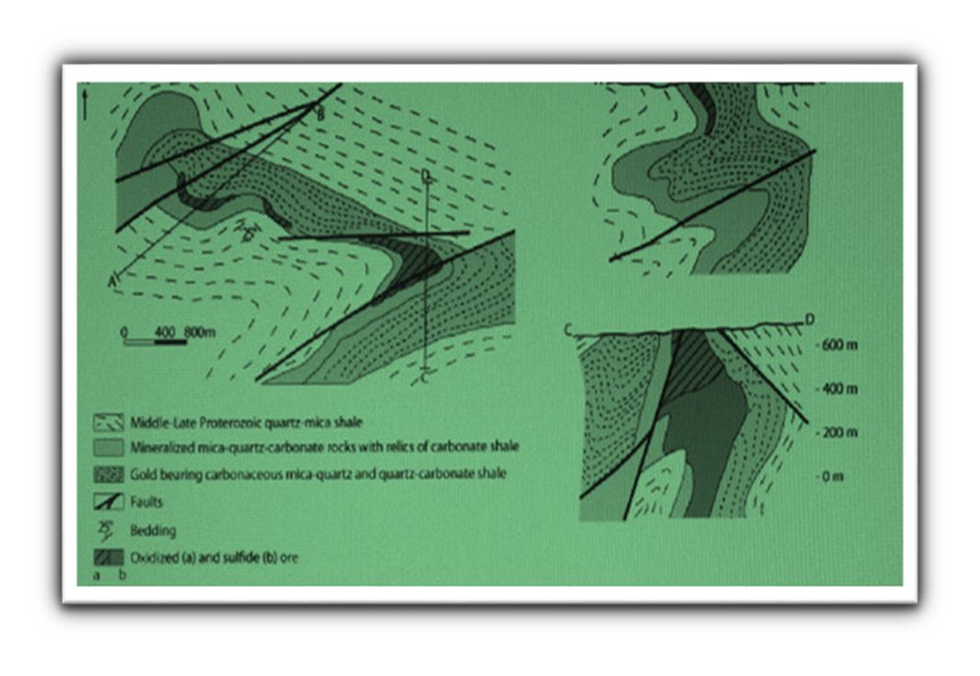
The stratiform type ore bodies are lenseslike zones of veinlets and disseminated mineralization. The main ore body is traced for about 600 m at the eastern part of the deposit and contains 90% of resources, while three ore bodies on the western flank contain about 10% of the total resource. The ore bodies are localized in flexurelike bends of fold structures and are commonly located in the limbs of inverted and recumbent folds along the tectonically disturbed contacts of the carbonaceous shales and marble with quartz-mica-carbonate rocks. The thickness of the ore bodies varies from 1-2 m at the limbs of folds up to 40 m at the fold bends while the main ore body is reaching 150-170 m at the fold bend. Ore bodies commonly do not have distinct contacts and are outlined mainly by sampling.

Figure 1. Geologic model of the Olimpiada deposit (modified after Konstantinov and Narseev 1989).
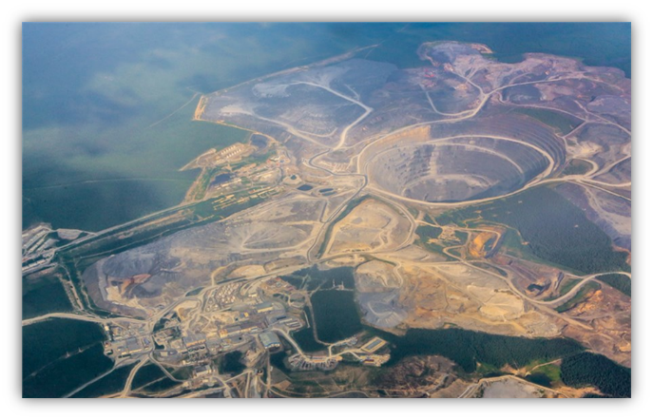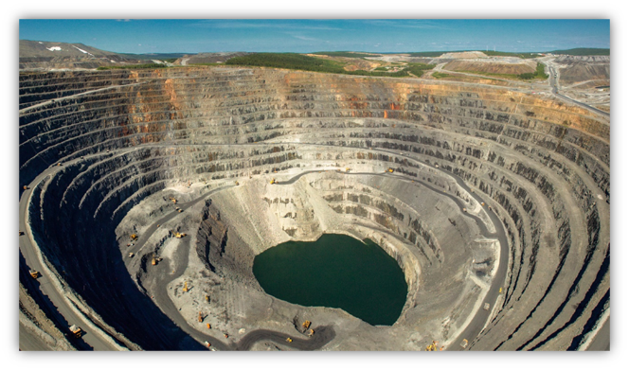
Quarry of the Olimpiada deposit

Mineralization
Disseminated and veinlet-disseminated gold mineralization contains from 2-5 to 12% sulfides, mainly pyrrhotite, arsenopyrite, pyrite, and stibnite. Lesser amounts of scheelite, chalcopyrite, sphalerite, galena, gray copper ore, and native antimony are also present. Cinnabar, jamesonite, gudmundite, bismuthinite, and berthierite are rare. The earliest (pre-gold) quartz-scheelite mineral association forms disseminations or thin quartz- scheelite stringers in the banded, metasomatic carbonaceous sericite-quartz and zoisite-carbonate-quartz rocks (Genkin et al. 2002).
The main gold-bearing association consists of arsenopyrite, pyrrhotite, and pyrite. Pyrrhotite is the most widespread sulfide and forms idiomorphic grains and clusters. Monomineral pyrrhotite without visible gold particles contains, according to S. Yablokova (TsNIGRl), up to 150 g/t gold. Native gold sometimes associates with second generation of pyrrhotite at the core of ore bodies containing abundant arsenopyrite and stibnite mineralization.
Small acicular and prismatic crystals of arsenopyrite, from 5 pm to 2 mm in size, constitute up to 5% of ore but are not known outside of the ore bodies. Arsenopyrite contains often inclusions of other minerals and submicroscopic particles of gold. The gold content in an individual arsenopyrite grain varies from 140 to 2,600 ppm (Genkin et al. 2002). Pyrite is found both in the ore bodies in weakly altered carbonaceous, mica-quartz shales and usually contains low level of gold, at least 10 times less than that found in pyrrhotite.
Native gold (920-1,000 fineness) forms very thin (0.005 to 0.05 mm) inclusions in pyrrhotite, arsenopyrite, and very rare in stibnite or nearby of these minerals in quartz. Aurositbite also associated with arsenopyrite in a form of inclusions ranging between 2 and 105 µm in size.
The average gold grade for primary ore of the Olimpiada deposit is 4.6 g/t but reaches 10.9 g/t for oxide ore. In addition, the ore contains up to 0.1% of W2Oy Oxidation of reported Cretaceous-Paleogene age with abundant clay substance, ocher, and quartz spills can be traced to the depth for more than 350 m at the eastern part of the deposit. Gold in the oxide ore is mainly free.
The age of the Olimpiada deposit (Distanov et al. 1975) is between 794 Ma (age of pre-ore metasomatic alteration) and 609 Ma (age of late-stage antimony mineralization).
Total in situ gold resources of the Olimpiada deposit including oxide and sulfide ore are estimated as 22.5 Moz or 700 t (Nekrasov 2005). Cumulative production of gold at the deposit, mainly from the oxide zone through the beginning of 2006, exceeds 200 t.
The Olimpiada deposit is the only veinlet-disseminated deposit of gold (arsenic)-sulfide mineralization in the Middle-Upper Proterozoic carbon-bearing black shales in the CIS. Its mineralization has stronger stratiform character than the other deposits of this type; the highest gold grades occur not in arsenopyrite but in pyrrhotite, and gold is unusually associated not only with arsenic but also with tungsten.

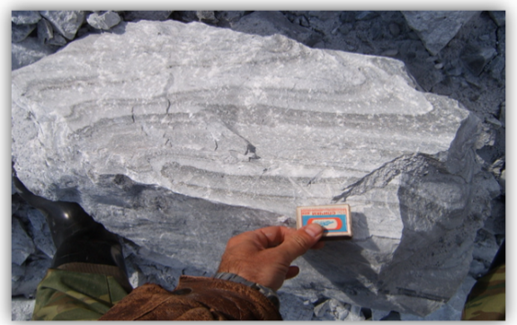
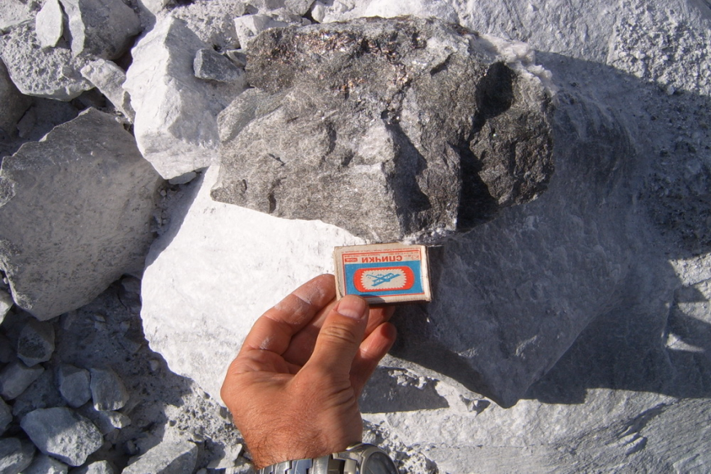
Samples of ore deposits Olimpiada - banded carbonate-mica-quartz metasomatites with sulfides (arsenopyrite, pyrrhotite, pyrite)

Quarry “Eastern”
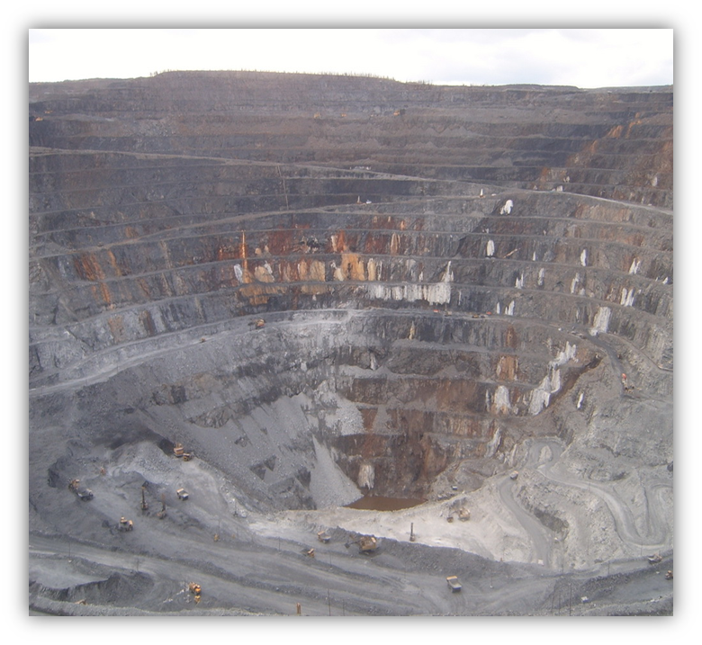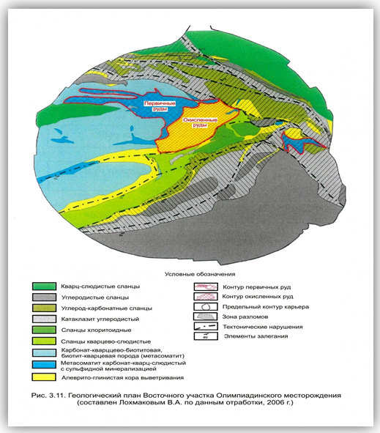
The Kumtor lode gold deposit

The Kumtor lode gold deposit, located in the eastern part of the Kyrgyz Republic (Central Asia).
The deposit was discovered only in 1978.
Kumtor is 100% owned Canadian gold mining company, Centerra Gold Incorporated.
Contains 288 t of gold at a grade of 3.57 g/t.
The district is within the zone of seismic hazard corresponding to the 8th step in the Richter scale.
Widespread permafrost spreads down to a depth of 150–200 m.
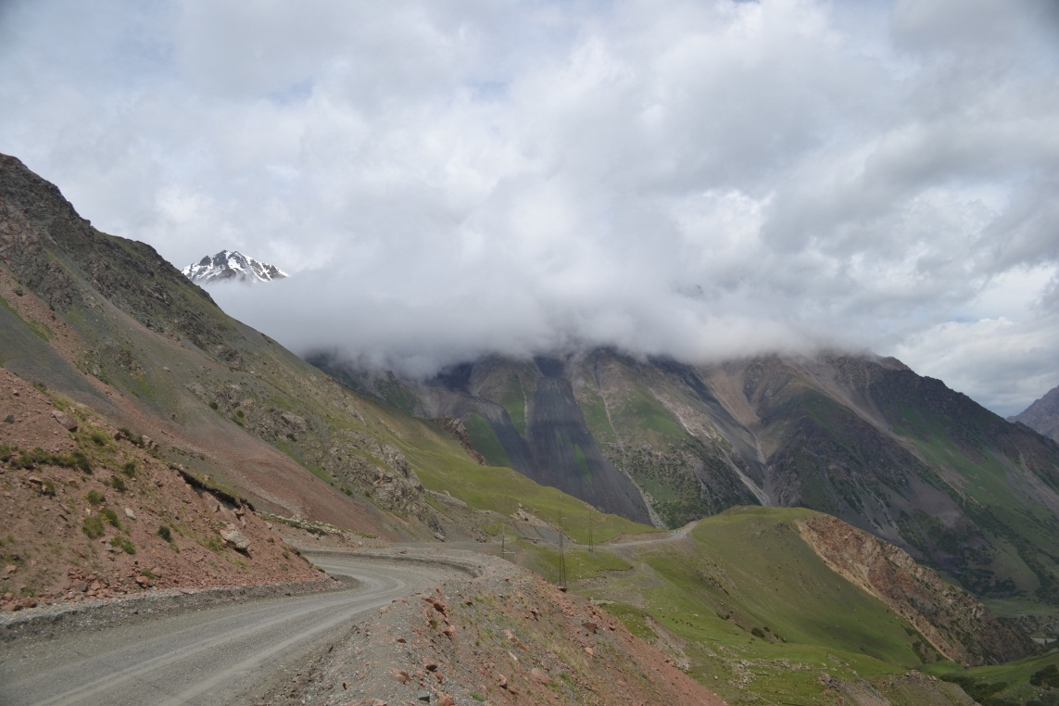

Fig. 1. The road to the Kumtor deposit in the gorge Barskoon. The road runs at a height of 3500 meters above sea level.

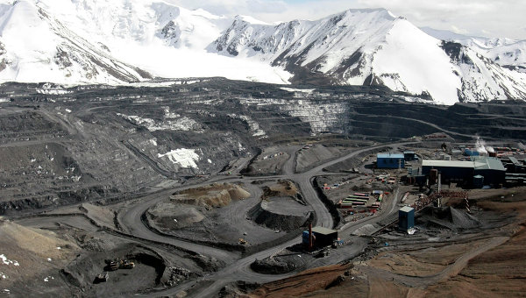

Fig. 2. The quarry is located at a height of over 4,000 meters above sea level in the permafrost zone.

The Kumtor deposit is localized in the backarc magmatic belt of the Middle Tien Shan close to the Nikolaev Tectonic Line of regional importance. The Kumtor ore field is related to a belt of black shales in the zone that conjugates the pre-Riphean basement of the Saryjaz Median Mass and Late Caledonian structures of the Jetymtau Trough.
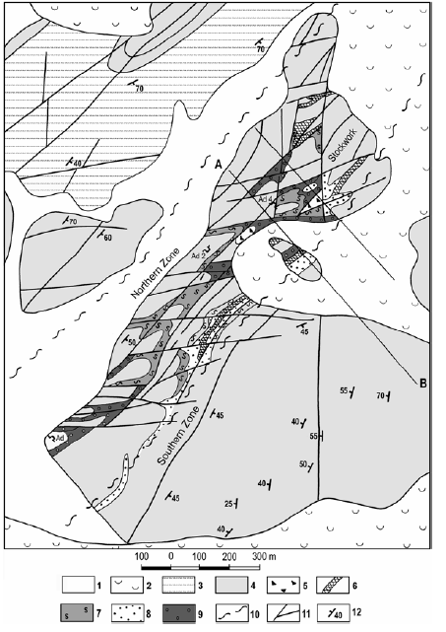

Fig. 3. Geological map of the Kumtor gold deposit.
1 — Quaternary sediments; 2 — glacier; 3 — Cambrian–Lower Ordovician: marble, lidite; 4 — Vendian: carbonaceous cherty slate, phyllite, tillite-like conglomerate; 5 — explosion breccia; altered rocks: 6 — carbonate–quartz–pyrite, 7 — quartz–sericite, 8 — pyrite–K-feldspar–carbonate, 9 — pyrite–albite–carbonate; 10 — ore-controlling thrust-fault zones; 11 — faults; 12 — strike and dip symbols.

Paleoproterozoic metamorphic rocks of the Kuilyu Formation intruded by Riphean granitoids make up the base of the stratigraphic section of the ore-bearing zone. The eroded surface of these rocks was overlapped with an angular unconformity by Upper Riphean volcanogenic and sedimentary rocks of the Kashkasui Formation composed of intercalated foliated conglomerates, metagritstones, metasandstones, and metavolcanics of bimodal basalt-rhyolite association.
Fault tectonics
Faults play the most important role in the structure of deposit. In addition to premineral thrust faults that divide the sheets of various rocks, extended upthrow faults close in age to mineralization are extensively developed. They are traced in NE direction within tectonic sheets complicating the thrust faults. Meridional and latitudinal faults are commonly shorter and occur less frequently. The mineralized zone extends for 10 km (geochemical and heavy concentrate haloes, for 50 km) along the Kumtor Thrust Fault that dips southeastward at angles of 30–50º.

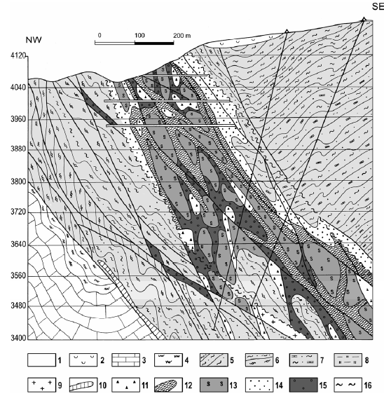

Fig. 4. Geological section across the Kumtor gold deposit along exploration line 62.
1 — Quaternary sediments; 2 — glacier; Cambrian–Lower Ordovician rocks: 3 — marble, 4 — lydite; Vendian rocks: 5 — Baikonur Formation, phyllite; Jetymtau Formation: 6 — foliated tillite-like conglomerate, 7 — silty–sandy carbonate phyllite, 8 — carbonaceous cherty slate; 9 — Riphean granite; 10 — Paleogene trachydolerite; 11 — explosion breccia; hydrothermally altered rocks: 12 — carbonate– quartz–pyrite, 13 — quartz–sericite, 14 — pyrite–K-feldspar–carbonate, 15 — pyrite–albite–carbonate; 16 — ore-controlling thrust-fault zones.

The Kumtor ore field is hosted in a Vendian carbonaceous flyschoid sequence and overlying carbonate rocks of Cambrian and Lower Ordovician age.
Plateau ages for whole-rock samples of sericite-quartz altered rock and sericite-bearing gold ore are 285.5 ± 1.2 and 288.4 ± 0.6 Ma. Sericite concentrates gave plateau ages of 284.3 ± 3.0 (host rock) and 285.4 ± 0.2 (ore) Ma.

At the Kumtor deposit, the orebodies are strictly confined to the tectonic melange within the Mineralized Thrust Fault Zone. All lodes are closely spaced, interconnected, and enclosed into common haloes of metasomatic alteration.
In the Central area, the Main mineralized zone, 100–300 m thick, extends for 1250 m and dips to the southeast at angles of 40–60º. The zone is composed of quartz–sericite–chlorite slate. On the footwall, it is bordered by the Northern Fault, and on the hanging wall, by the Southern Fault. Within the zone, the rocks are fractured, carbonatized, and brecciated; gouge is observed along fault surfaces. A multitude of northeastern faults bounds narrow elongated blocks consisting of variously deformed and metasomatically altered rocks. Gold mineralization, geochemical haloes, and alteration zones are traced along such faults. The Southern, Northern, Northeastern ore zones and a Stockwork were contoured within the Main Mineralized zone.

In the upper levels, the pyrite–carbonate–K-feldspar mineral assemblage with gold of high fineness is most abundant. The superposition of a late pyrite–hematite–carbonate association resulted in the regeneration of early gold and deposition of late gold in high-grade ore of the Stockwork and at upper levels of the Southern ore zone. The less productive carbonate–albite and pyrite–(carbonate)–quartz assemblages occur at the lower levels. The superposition of pyrite–hematite–carbonate assemblage yields the gray massive or banded ore with a higher grade.
Ore grades vary from 1.2 g/t (the lowest exploitable grade) to over 70 g/t and are generally correlated to pyrite content.
Ore shoots are confined to areas with high hydrothermal minerals/host rock ratio such as intensive stockwork, hydrothermal breccia, or banded carbonate-pyrite rocks formed in the late stages of mineralization

GIANT MURUNTAU GOLD DEPOSIT IN USBEKISTAN
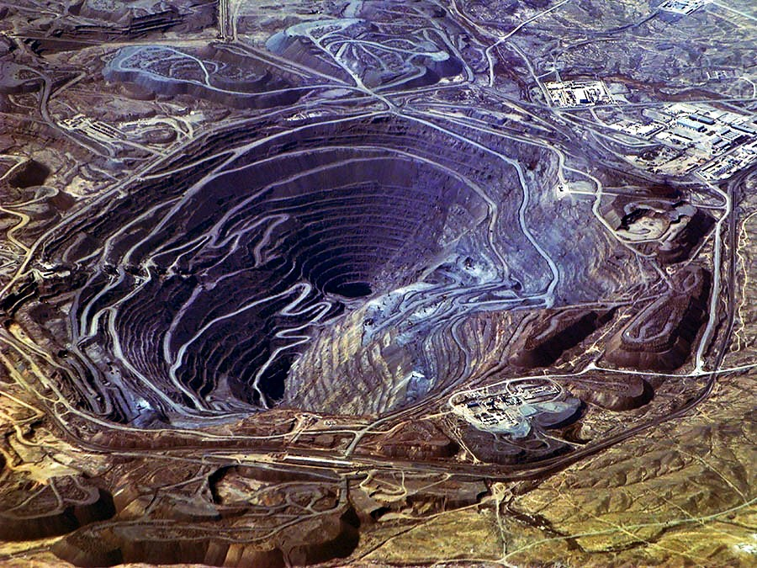
Picture 1 (MURUNTAU GOLD DEPOSIT)

The giant Muruntau gold deposit of Uzbekistan has a resource, including production, of about 170 million ounces (Moz) of gold (Anonymous, 1996).
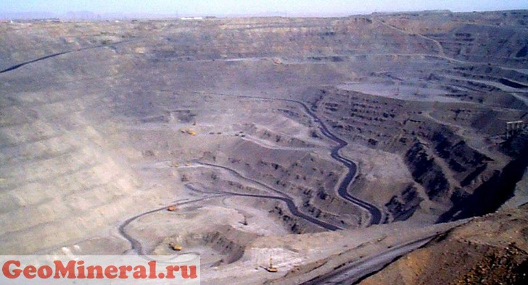
Picture 2 (Pit of Muruntau deposit)
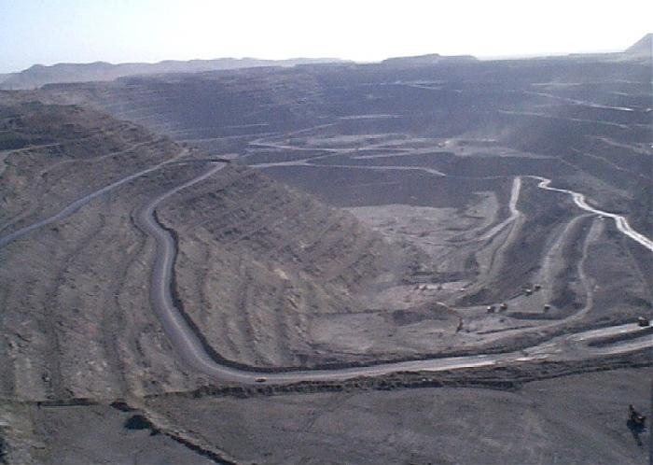
Picture 3 (Pit of Giant Muruntau deposit)
There are some contaminations in this deposit: silver, copper, bismuth, lead, arsenic, and iron.
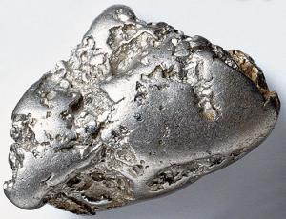
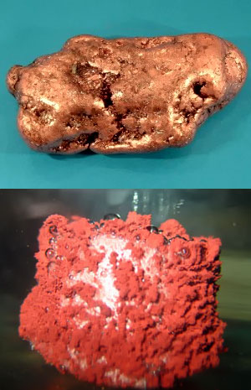

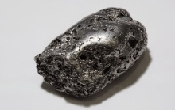

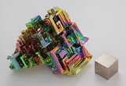
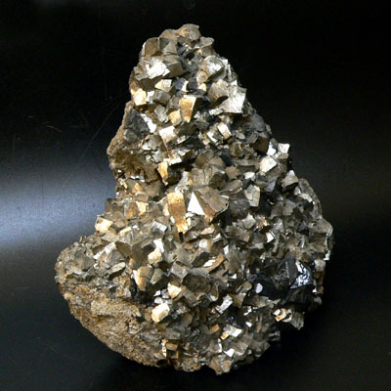

Picture 4 (Silver); Picture 5, 7 (Copper); Picture 6 (Iron); Picture 8 (Bismuth)
Picture 9 (Arsenic)
The deposit is situated adjacent to a major rift, which has been periodically active from the Devonian to the Tertiary and has accumulated a substantial thickness of chemical, volcaniclastic, and clastic sediments, including red beds and evaporites.
Muruntau deposit is so large because of the presence of a major source of reduced sulfur in these nearby evaporitic sediments, via thermochemical sulfate reduction.
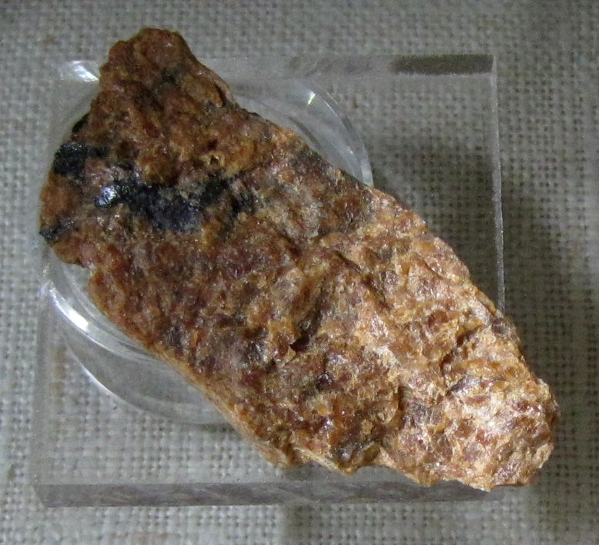
Picture 10 (Evaporit)

Some support for the role of reduced sulfur is provided by the presence of detectable H₂S in fluid inclusions from late-stage auriferous quartz veins. Reduced sulfur-rich fluids could have been focused into the depositional site along major northeast-trending structures, which have influenced rift-basin architecture as recently as the Jurassic. Oxidation is an important ore-precipitating process in this deposit. A change from early CH₄- to later syngold CO₂ - dominant fluid inclusions may be an indication of this process.
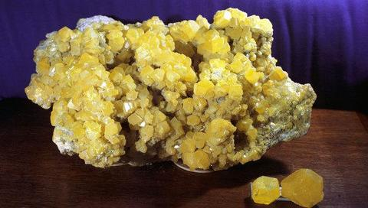
Picture 11 (Sulfur)

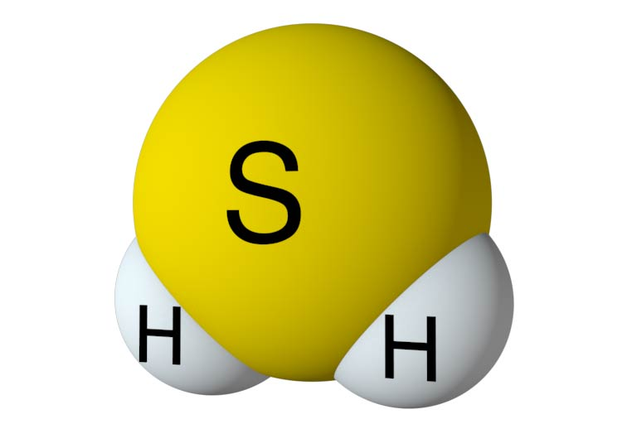
Picture 12 (Formula of Sulfur fluid)

- Northeast- and east-northeast-trending faults also show a strong spatial association with gold ore at Muruntau and at the small Besopantau and Cosmanachi deposits nearby.
- Immediately north of Muruntau, massive gray Devonian dolomite rests on the Besopan Formation. The contact is a low-angle fault, which dips northward, manifested as a zone of intense foliation and the presence of dismembered quartz.
- The contact between the Besopan 3 and 4 units is also a flat-dip-ping fault, the Sangruntau-Tamdytau shear zone. This shear zone extends through the Muruntau pit and is an important locus for ore and hydrothermal alteration.
- Northeast- and east-northeast-trending faults also show a strong special association with gold ore at Muruntau and at the small Besopantau and Cosmanachi deposits nearby.

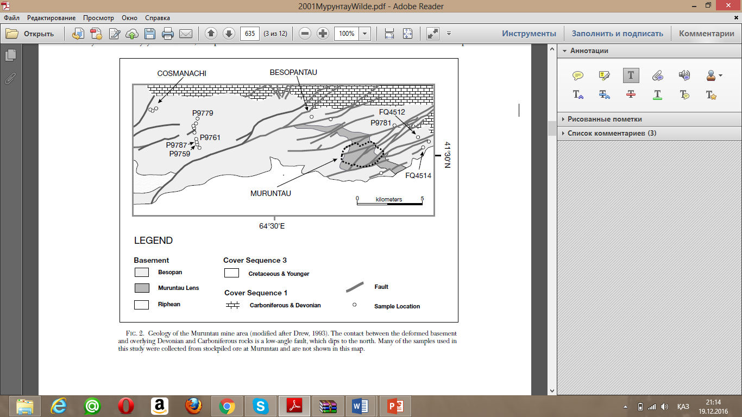
Picture 13 (Map of location Muruntau deposit)

Mironovskoe deposit

The Mironovskoe deposit is located to the southern Kastek Ridge 90 km eastward of Bishkek
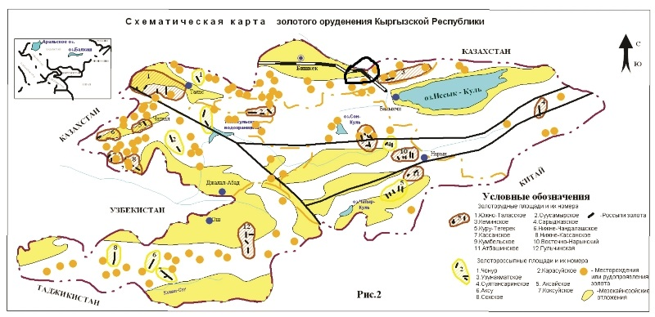
It was discovered at the end of the 1960s. The exploration was completed in 1976, however, since that time mining development has not started at the deposit. According to the proven Bi, Cu and Au reserves, the deposit is classified as a small one: 1 kt Bi, 80 kt Cu, and 2 t Au with 5% (up 2-3%) Cu, and 2-5 Au. The deposit area is composed of a layer of amphibolite (kuperlisayskaya suite), monoclinally incident on the DS. They are cut by intrusions of several magmatic complexes. On the northern flank of the deposit exposed gneissic granodiorite P3, in the central part-monzodiorites, adamelity and alaskites Oz and small stocks felsites O2-3. On the eastern flank of the field mapped sedimentary-volcanic strata with small bodies granosyenites P. All breeds are divided field network faults sublatitudinal, north-eastern and submeridional. Ore veins are controlled by steeply dipping faults sublatitudinal and north-easterly direction, intersecting both PZ1 amphibolites, and granites O3. Pronounced in the field of post-ore tectonics as thrusts with a gentle northwestern fall, biasing and cutoff steeply dipping ore bodies for all.

Schematic geological map
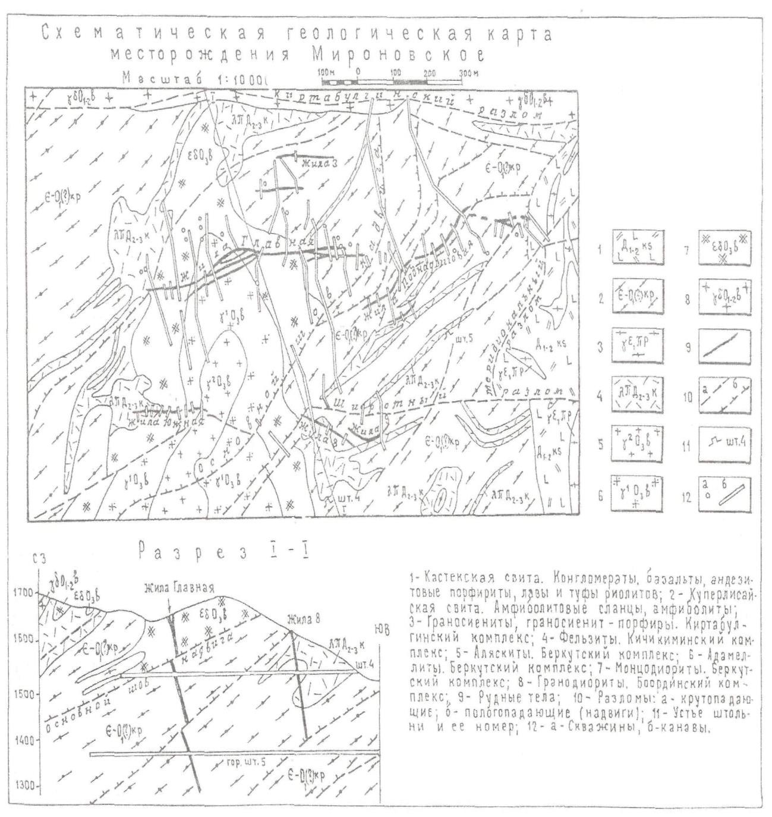
Major tectonic units os the Tien shan - a basic sheme
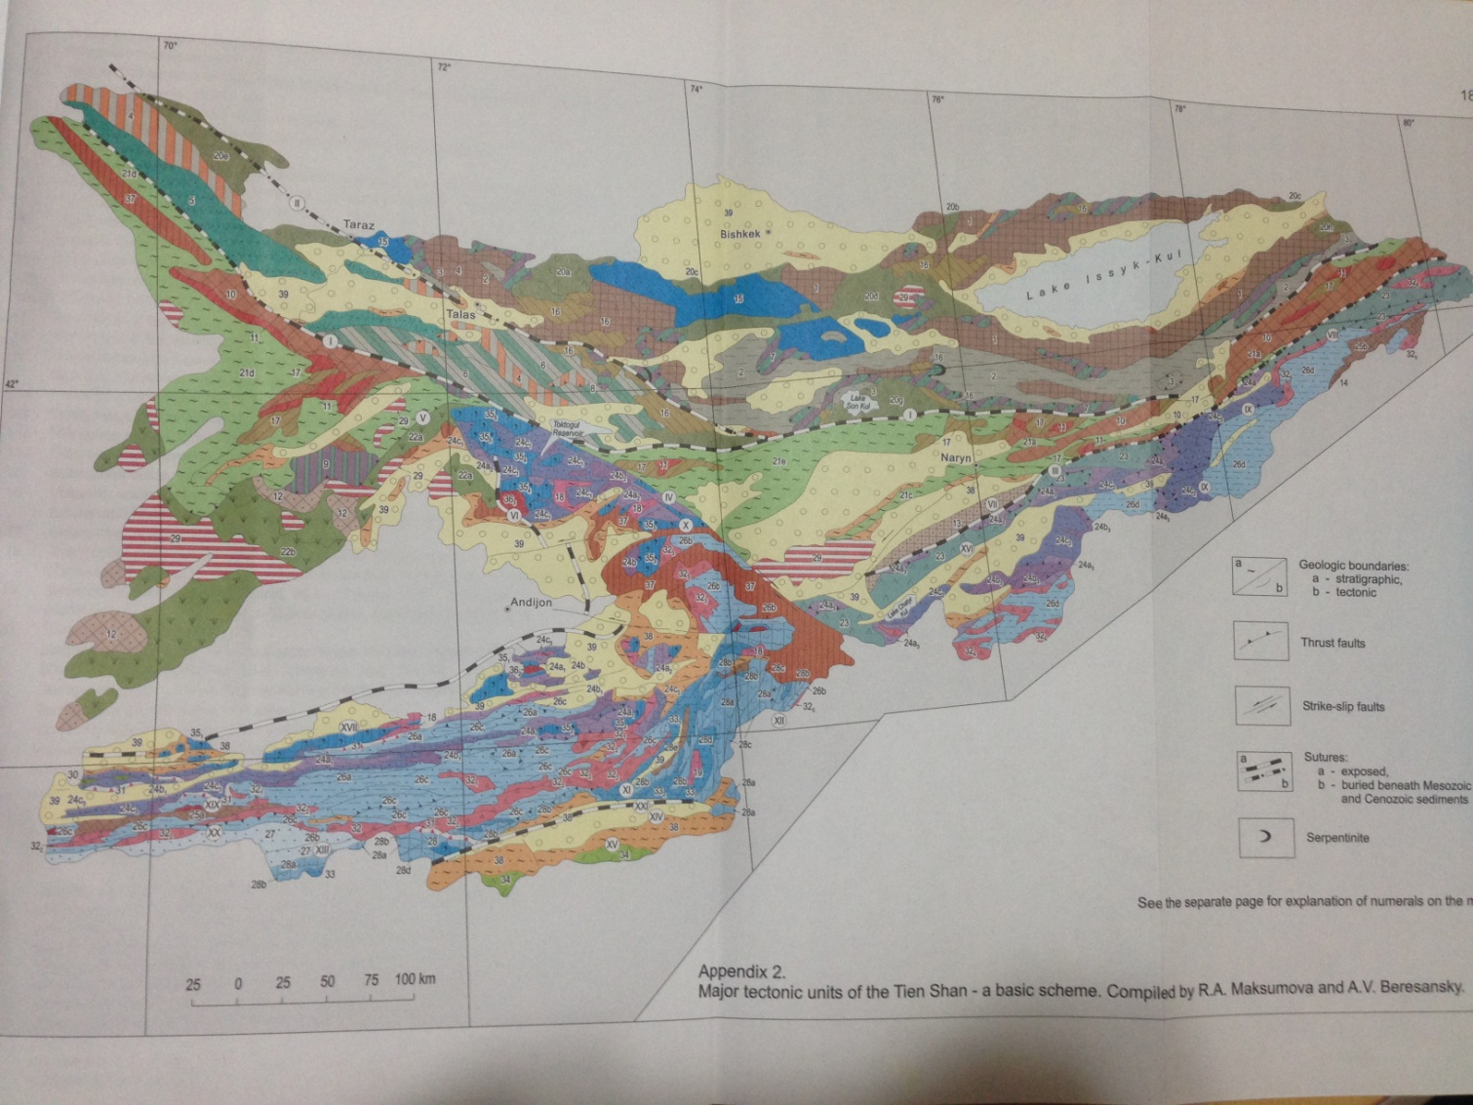

Geology of the ore field

The ore field is largely composed of Proterozoic amphibole schists (locally amphibolites of the Kuperlisai Group (Neoproterozoic) that form a monocline with NW-dipping schistosity. To north, the ore field is cut by the high-angle Kirtabulgha strike-slip fault as a boundary of granites related to the Kurdai Intrusive Complex of Middle Ordovician age. In the east and southeast, the ore field orders on the volcanic-plutonic ring structure consisting of two volcanic and plutonic rock associations of different a and composition (Fig. 10.1).
The older association is represented by silicic and intermediate volcanics of the Besheke paleovol- canic structure suggested to be Carboniferous in age; subaerial volcanics covered a heterogene- ous basement. The younger association is composed of closely related rhyolite, syenite porphyry gabbrodiorite, and monzogabbro that make up the Kirtabulgha laccolith and dike swarms in its framework. To the west, the ore field is bounded by the Maly Karabulak granitic pluton of the Kurdai Intrusive Complex. Southward, the ore field is hidden beneath Quaternary sediments of the Chu River Valley
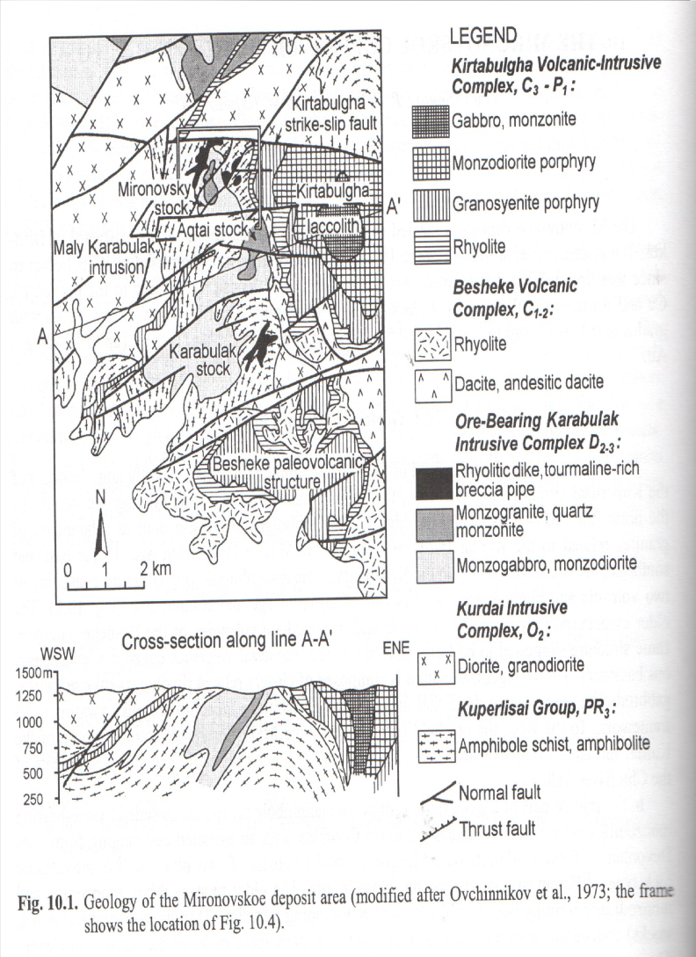

In the middle part of the ore field, Proterozoic amphibole schists are intruded by ore-bearing monzonite stocks of the Karabulak Intrusive Complex with an assumed age ranging from Late Devonian to Early Carboniferous. Monzonite stocks consist of two plutonic and subvolcanic rock types different in composition but close in age. The older monzogabbro, monzonite, and forming two W- and NW-dipping intrusions (Mironovsky and Karabulak stocks) concordant with the schistosity country metamorphic rock of the K Group tourmaline-bearing association is composed of occur as quartz p bodies related to rhyolite, and The younger rock small nite, rhyolitic breccia. rocks also contacts and interior of the above-mentioned stocks.
In total, 10 vein and lenticular orebodies are known at the deposit. Stockwork orebodies are of secondary importance. Ore-bearing veins are several hundred meter (up to 600-800 m) long, 0.5 to 2-3 m wide, and reach 400-500 m in vertical ex tent (Fig. 10.6)
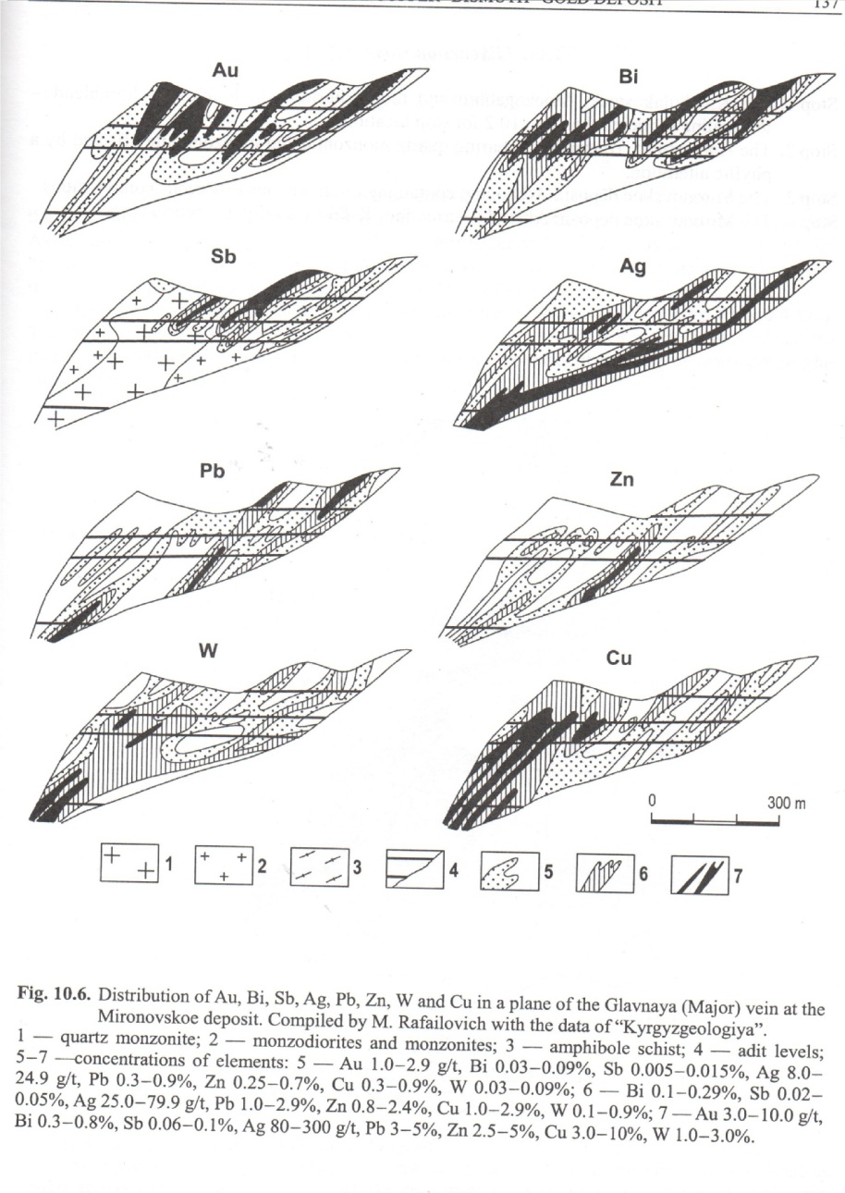

In 1974, reserves were approved by the State Reserves Committee of the USSR to a depth of 350 m in the following amounts
